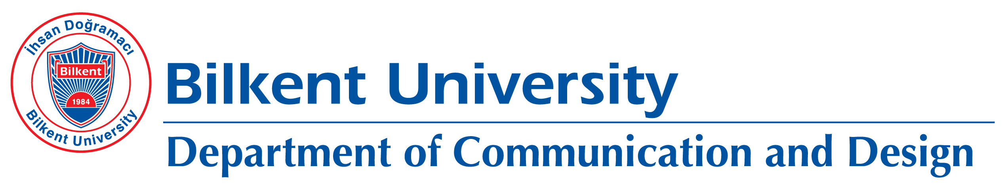

COMD 290 AND COMD 390 INTERNSHIP ROADMAP AND SCHEDULE

Internship Period: 4 Weeks (at least five workdays per week)

Required Steps:

- Request letter to be sent to the selected company
- Internship Place Approval Form and finalization of the internship dates
- Notification for SSI (SGK) entry, latest ten days before the start of the internship, when finalizing the internship dates
- Internship Evaluation Form
- Internship Report

2024 INTERNSHIP SCHEDULE

Sequential Procedures for Internship Applications | Final Application
Determining the places for internship and meeting with the instructor responsible for the internship,
Reception of the Application Letter to be sent to the company and the letter showing the acceptance and approval of the company (to be delivered to the instructor responsible for the internship).
The final form of the Internship Place Approval Forms (with the signature of the instructor responsible for the internship for SSI (SGK) transactions) This form is required and should be delivered to the department. | May 17, 2024
Confirming the internship dates and entering SSI (SGK) entries ten days before starting the internship | June 14, 2024
Submission of the Internship Evaluation Form (PDF) by the company directly to cigdem.karabag@bilkent.edu.tr The submission should be made using the corporate email address affiliated with the company. Alternatively, if a hard copy is chosen for submission, it should be ensured that it is enclosed in a sealed and signed envelope before being sent to the department. | October 18, 2024
Delivery of Internship Reports and Posters (in PDF format) via Moodle (Internship reports must be within the specified formats, and delays in reports submitted after the deadline will affect the grading of the report) | November 15, 2024
Internship Fair | The date will be announced later.

